Complete Diagram

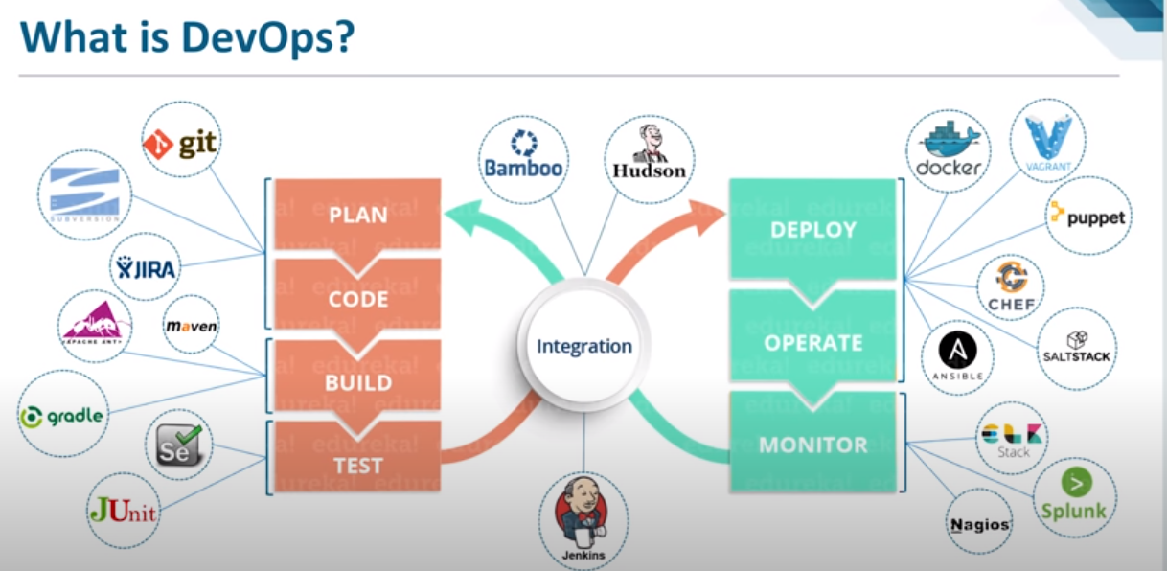

Planning + coding= Development

Most popular in development phase: Git

Most popular in build phase: Maven

In build, in do Java compilation, validate and unit testing

Heart of Devops 🡪Integration

Deployment + Operate 🡪Configuration Management System (Using a template, we can deploy the same thing in 1000 servers parallelly). Most Popular🡪Docker

Continuous monitoring of all devops application is required to check their health.

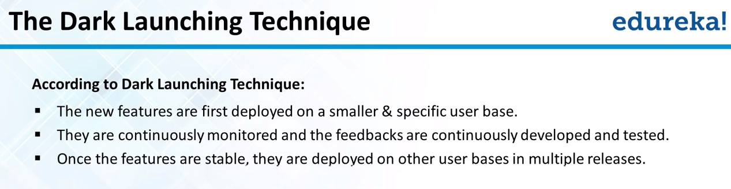

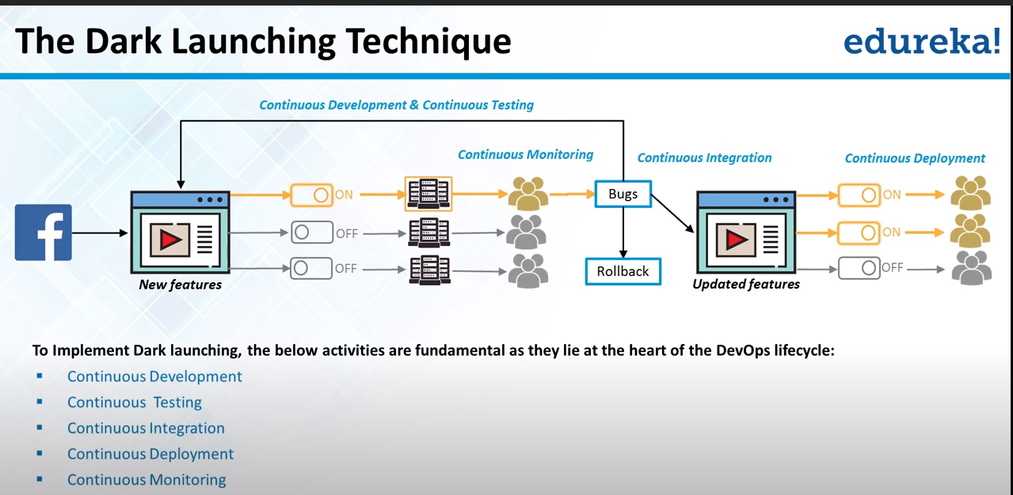

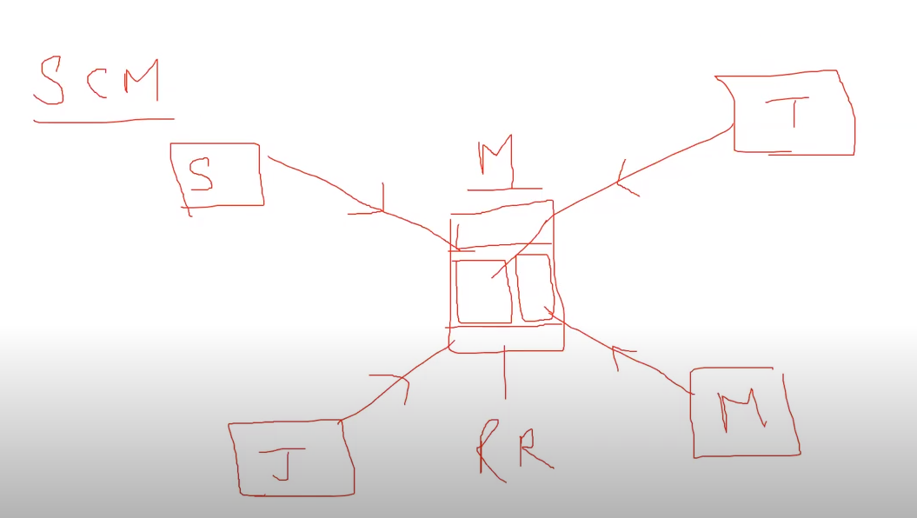

SCM🡪Source Code Management

RR🡪Remote Repository

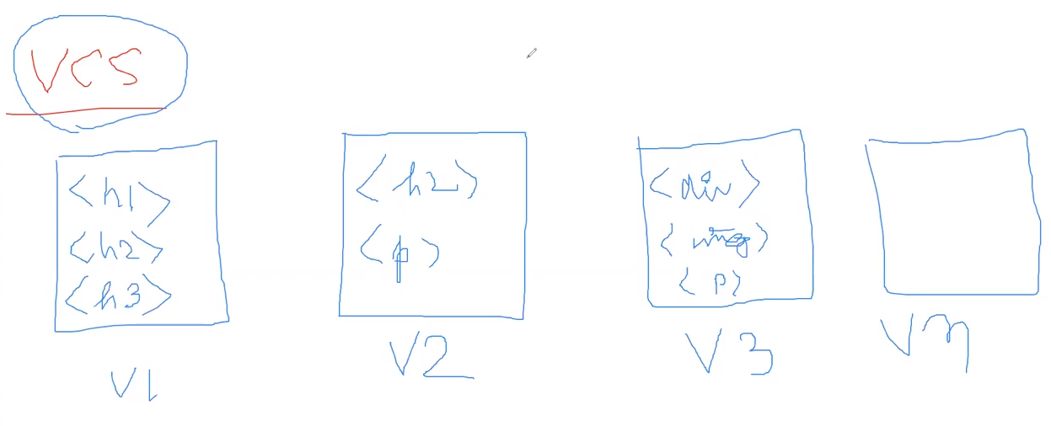

VCS🡪Version Control System

V1,V2..Vn🡪Versions

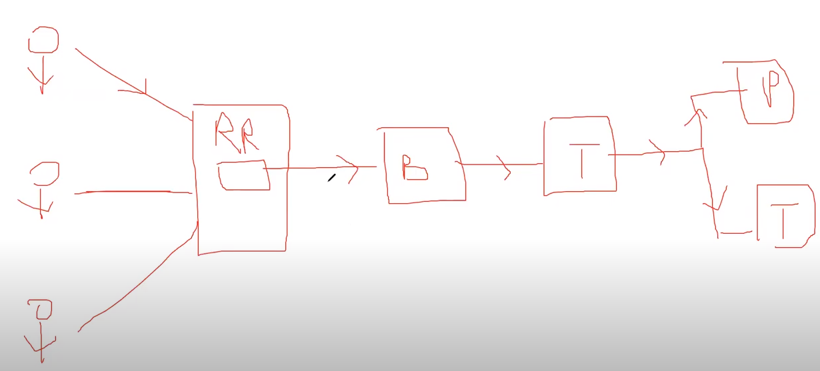

Developer🡪Remote Repository(RR)🡪Build(B) 🡪Testing(T)🡪Deployment either in Test (T)or Production(P)

This is called Continuous Integration tool🡪 Most Popular Jenkins

--------------------------------------------Github and GIT--------------------------------------------

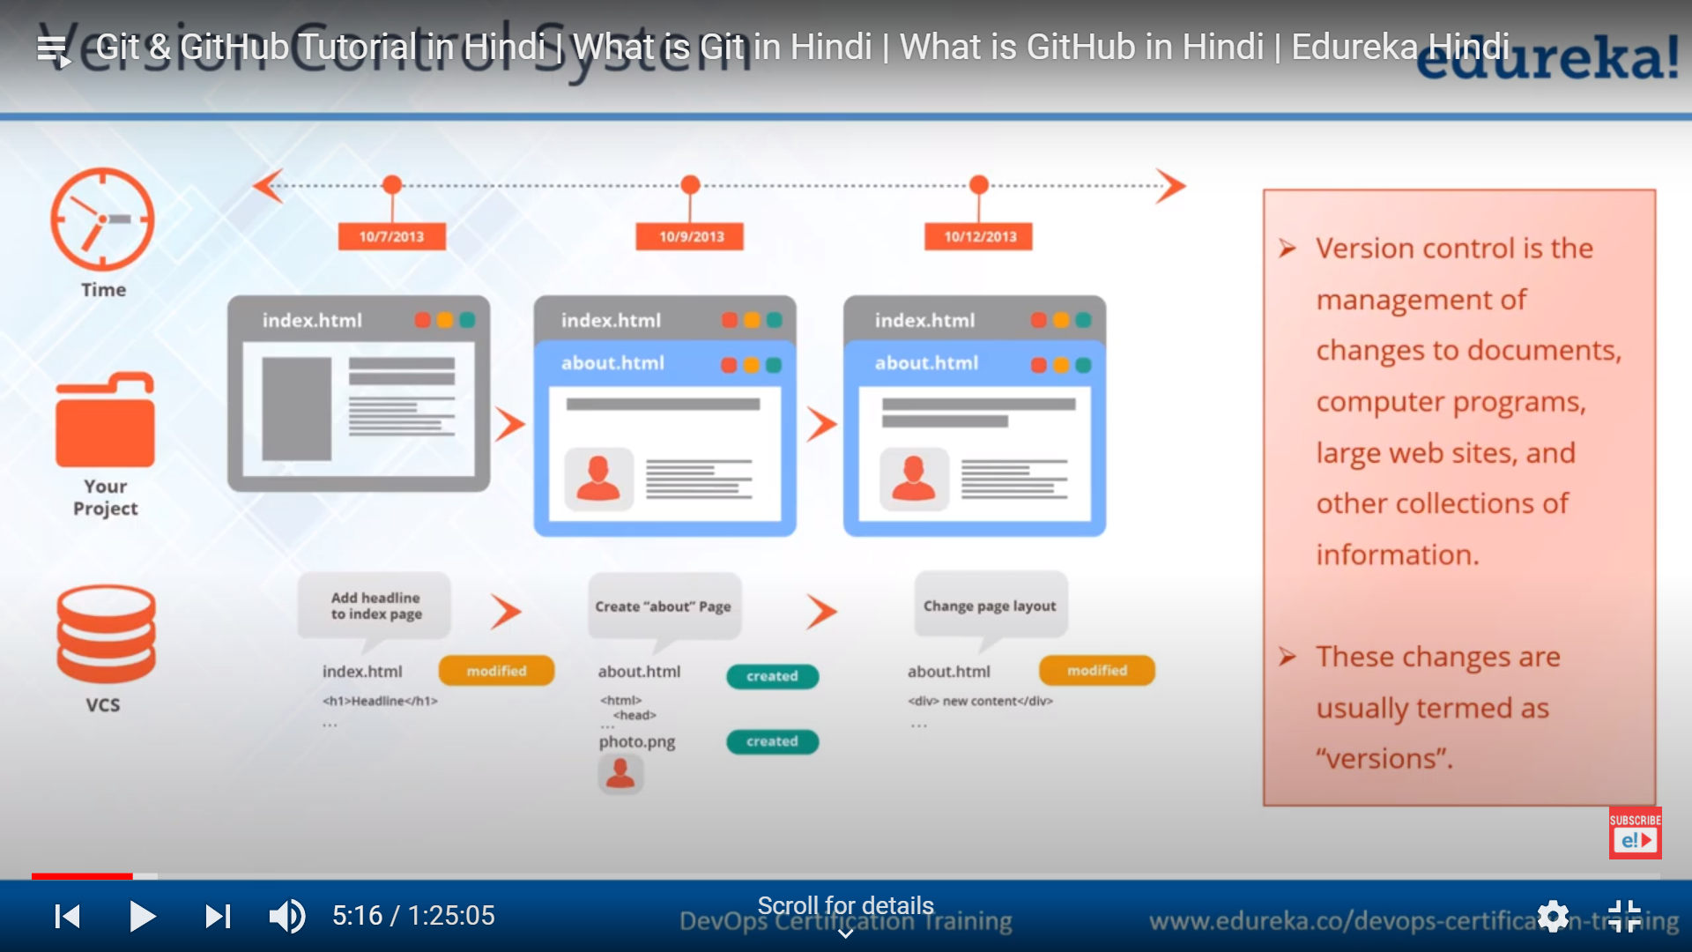

Why Version Control ?

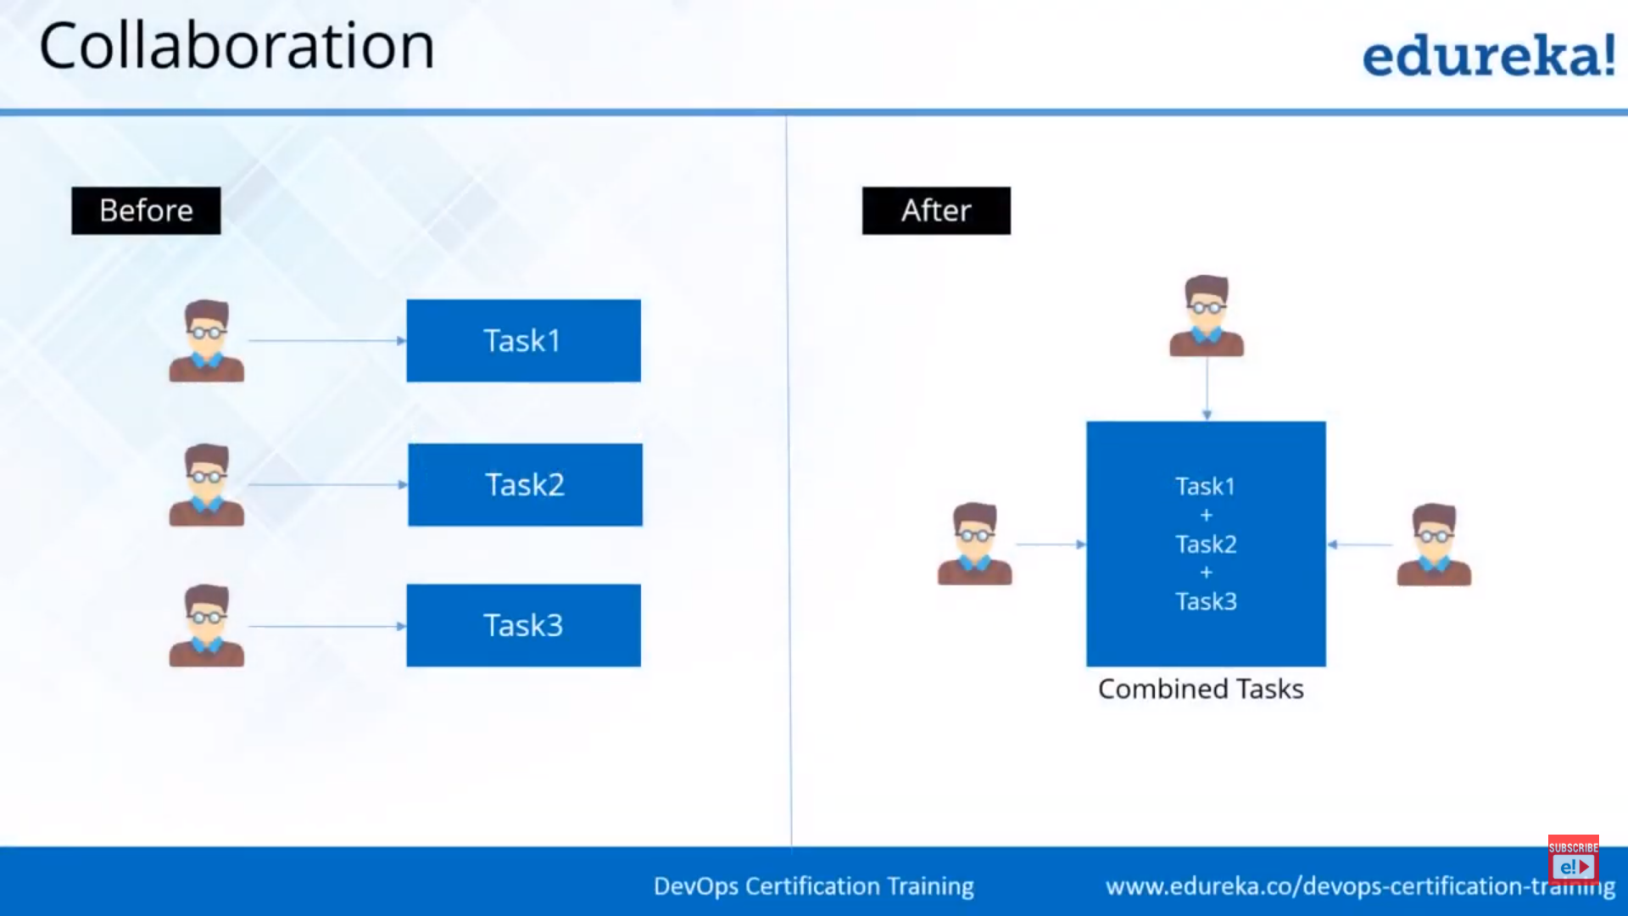

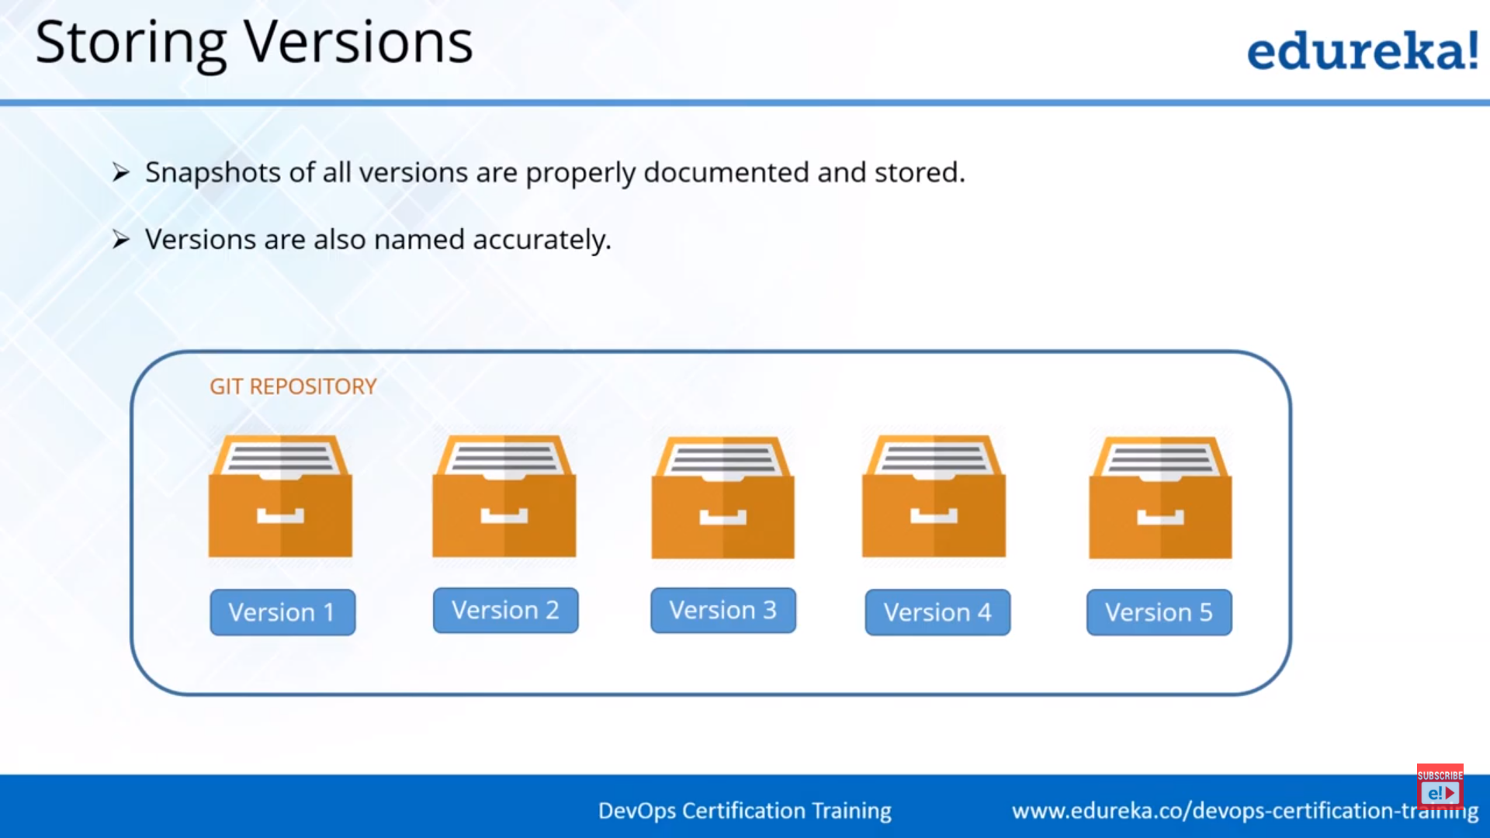

Snapshorts means incremental Backup

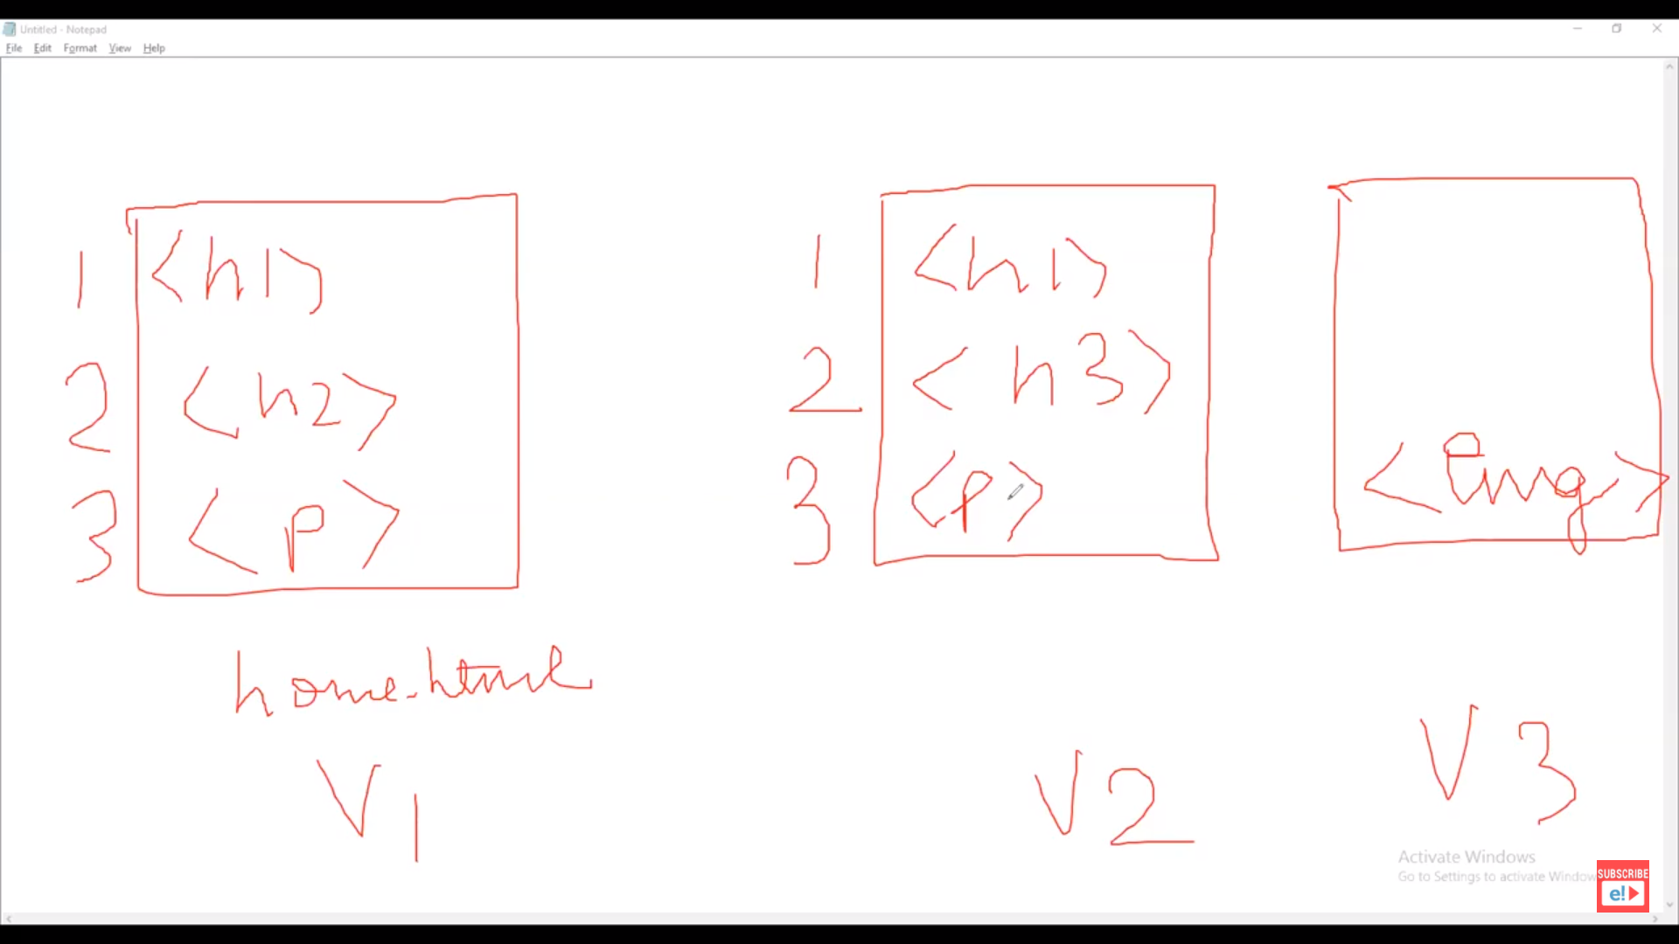

In V2 version, only the difference part (<h3> is different from V1) will be saved.

Similarly, in V3, only the <img> part will be saved. It is not present in V2.

Source Code management(SCM)

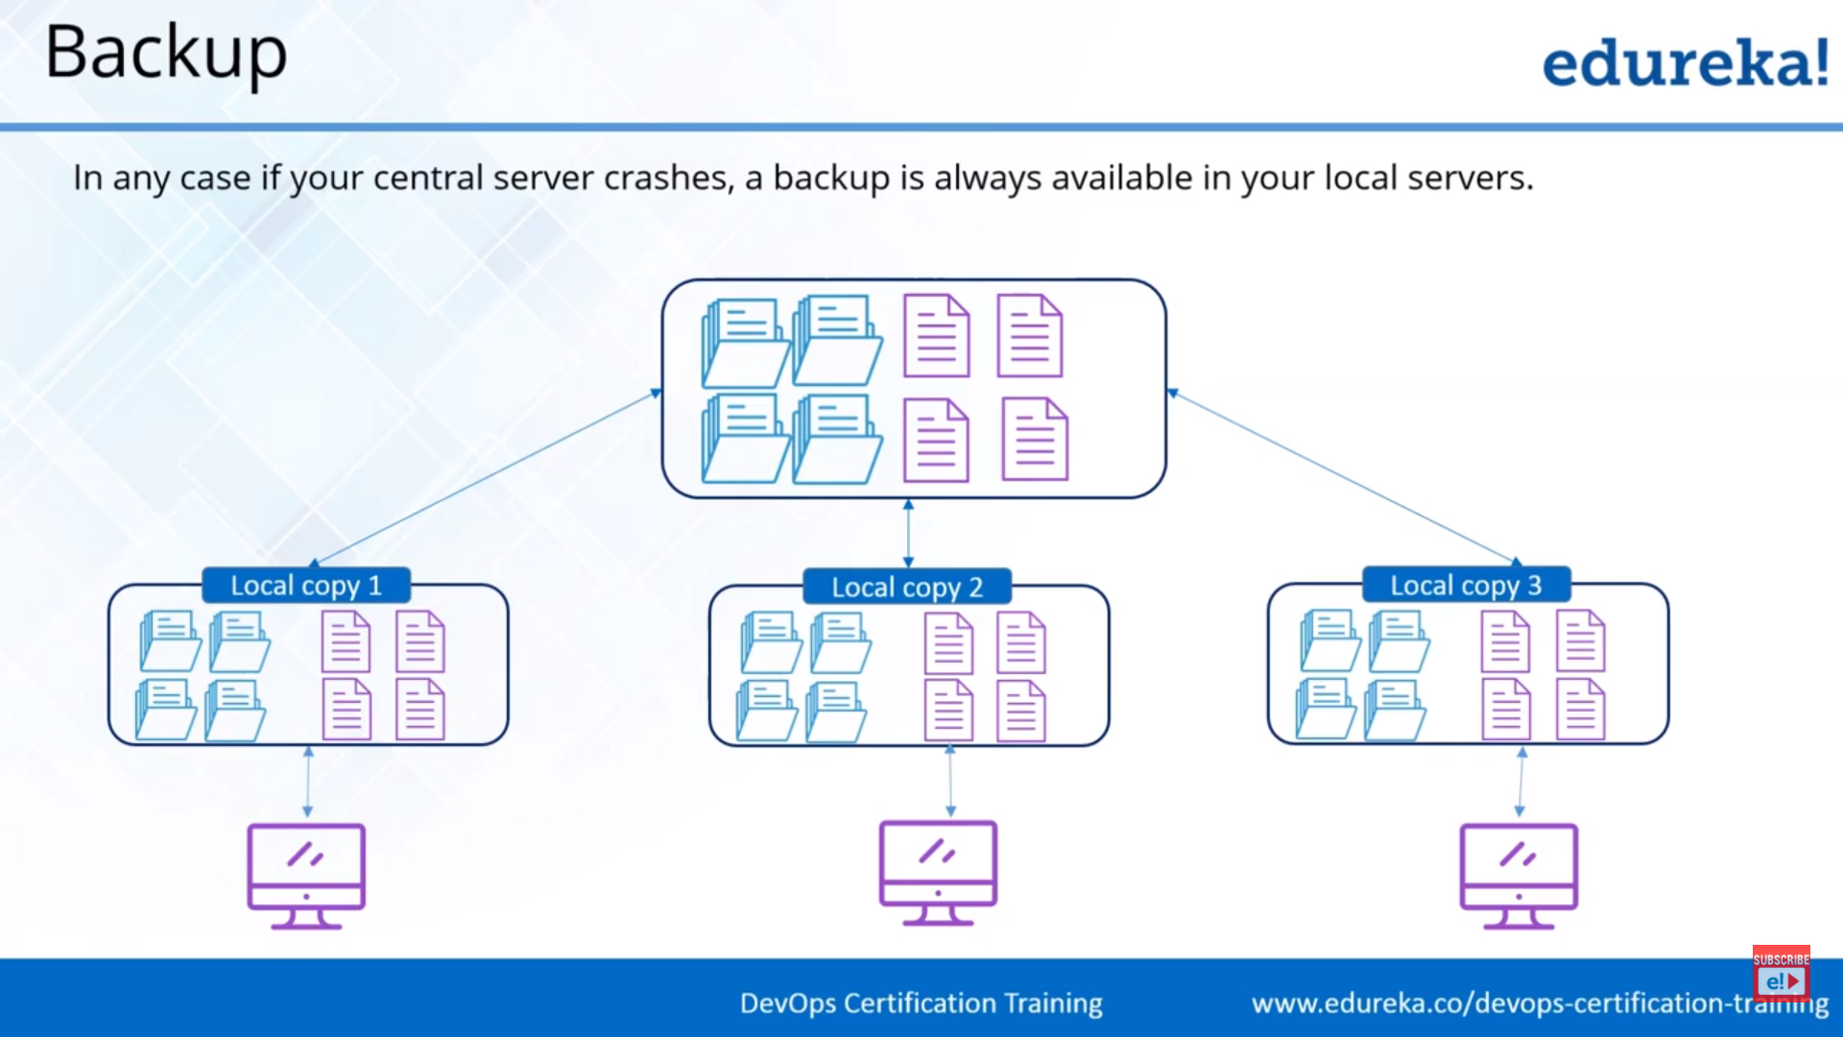

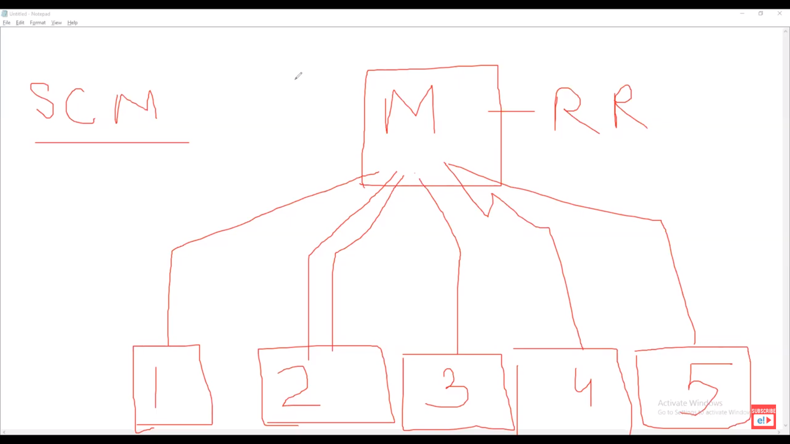

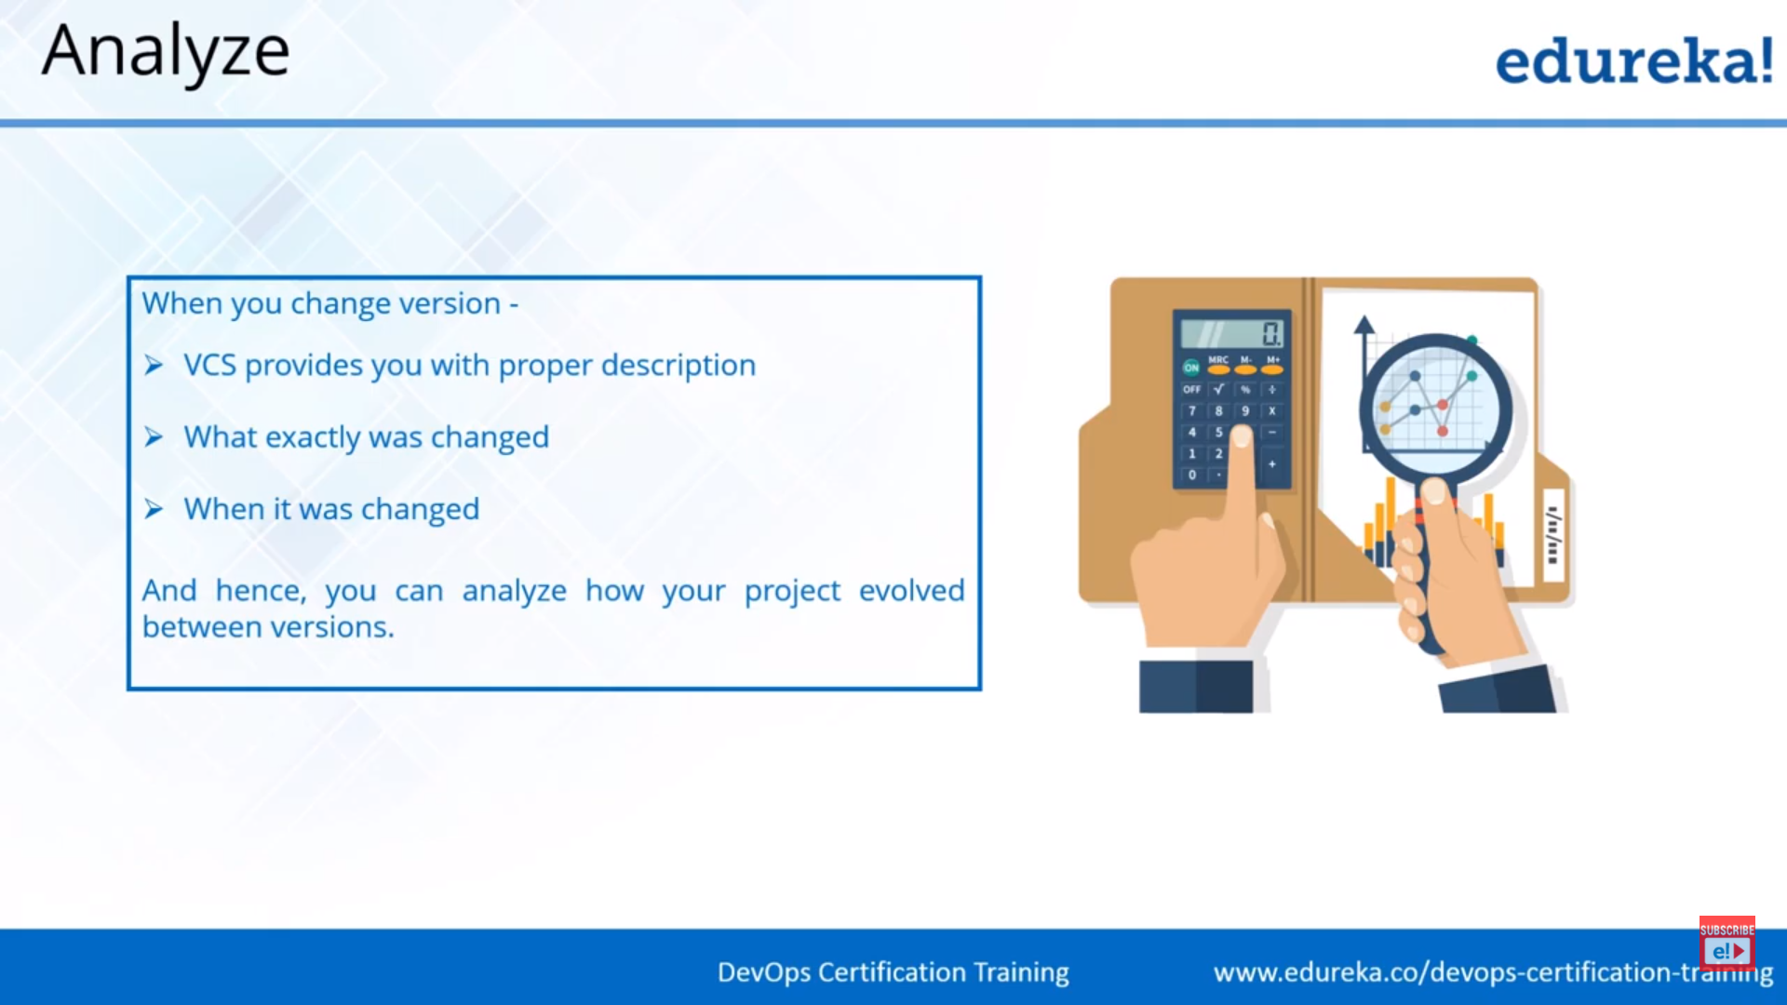

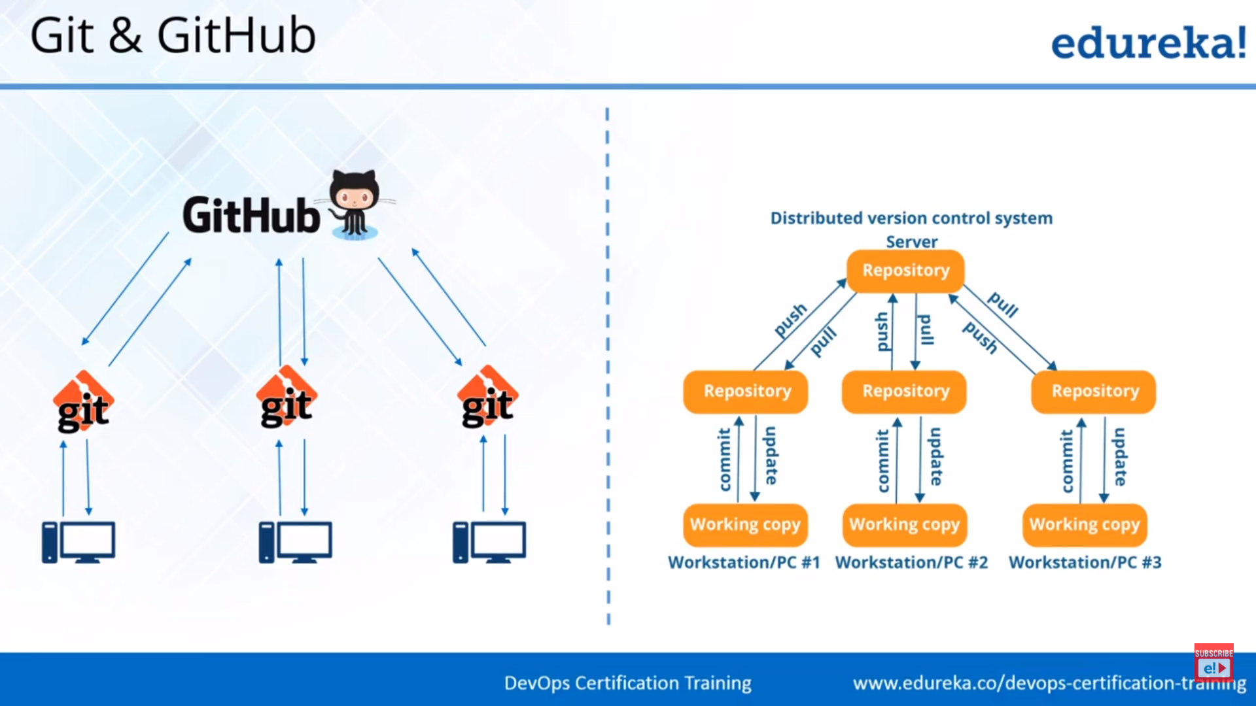

Version Control System is of 2 types

1. Distributed
2. Centralized

Git is a distributed version control system tool (DVCS)

Apache Subversion (often abbreviated **SVN**, after its command name **svn**) is a centralized version control system tool (CVCS)

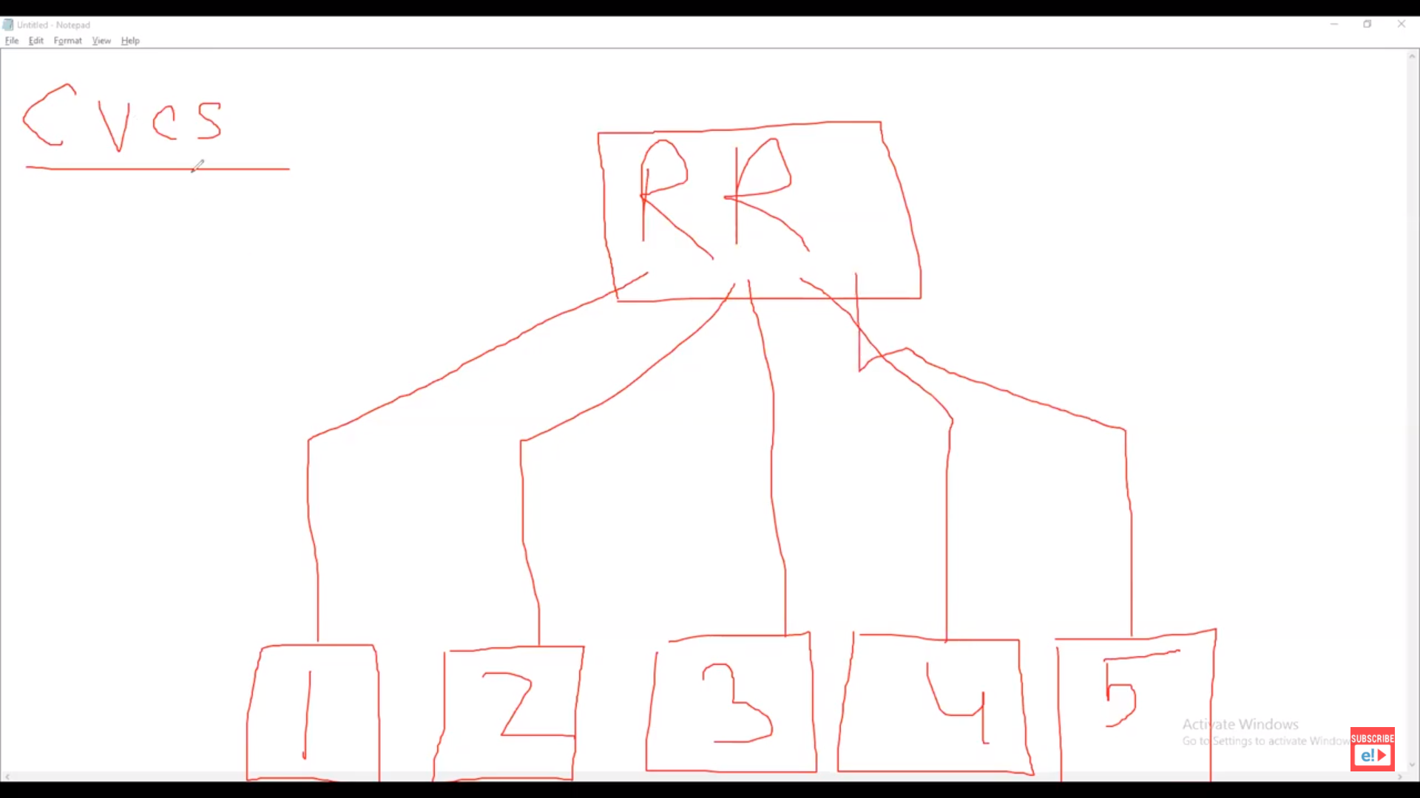

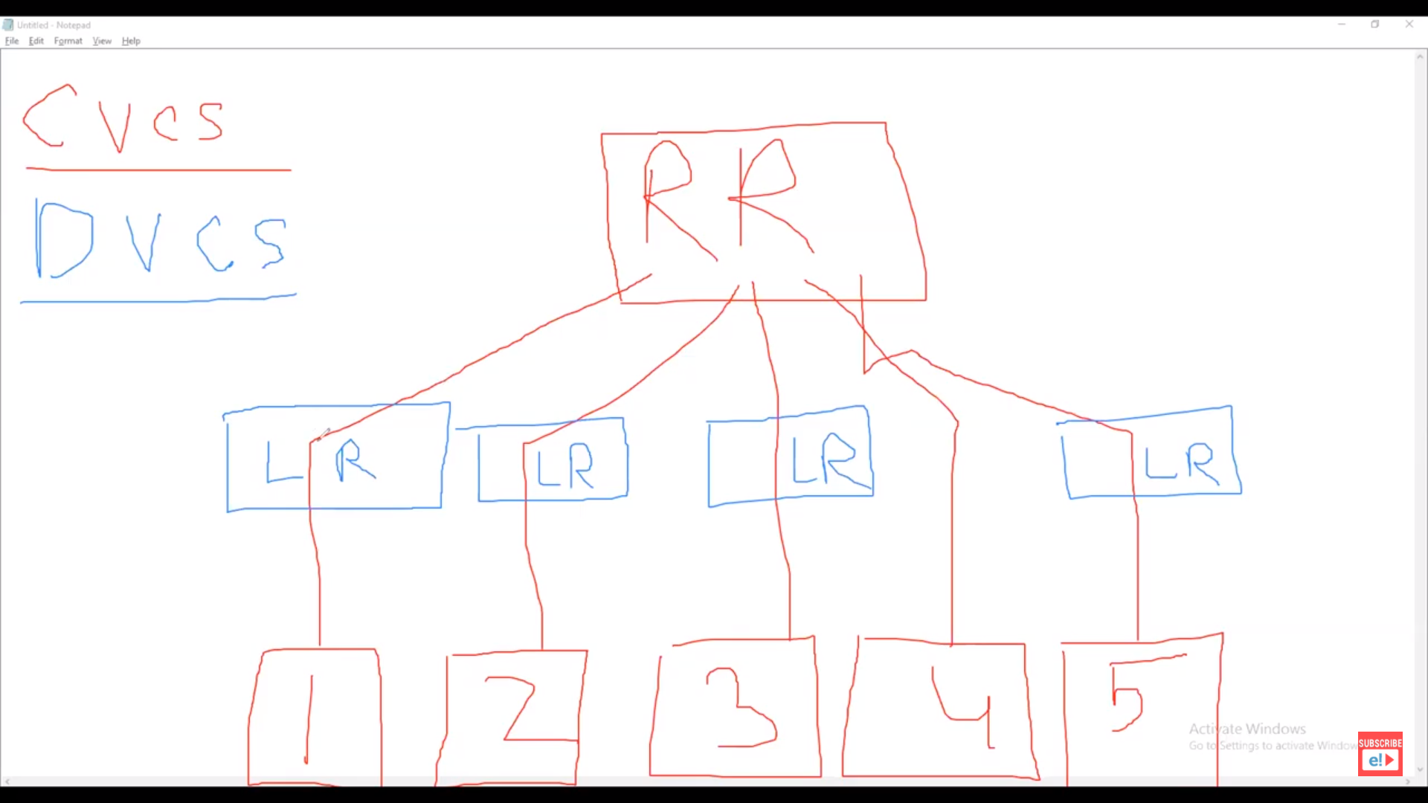

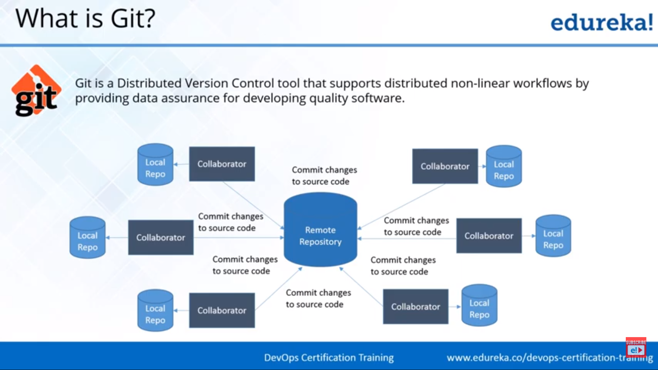

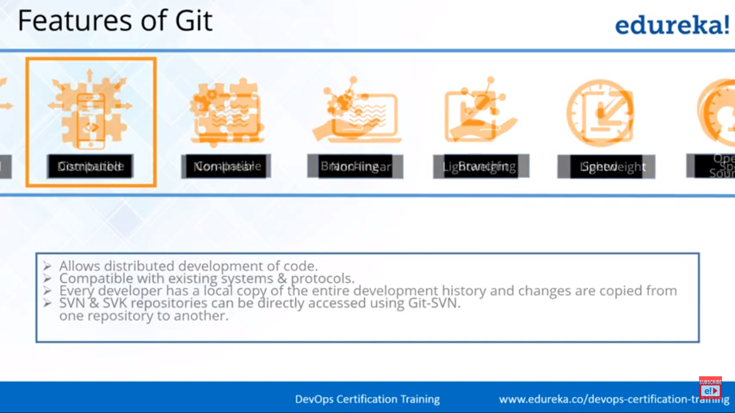

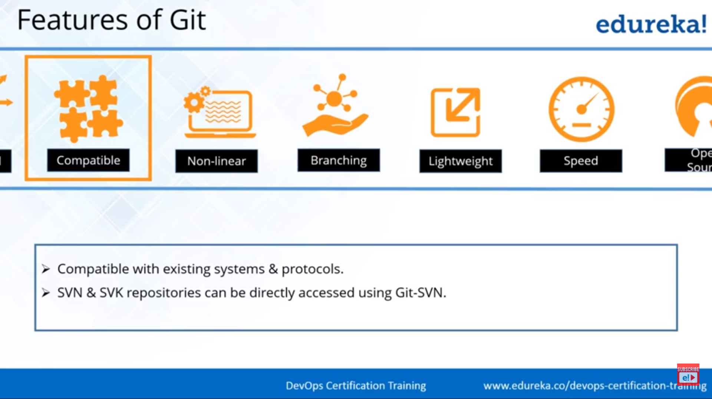

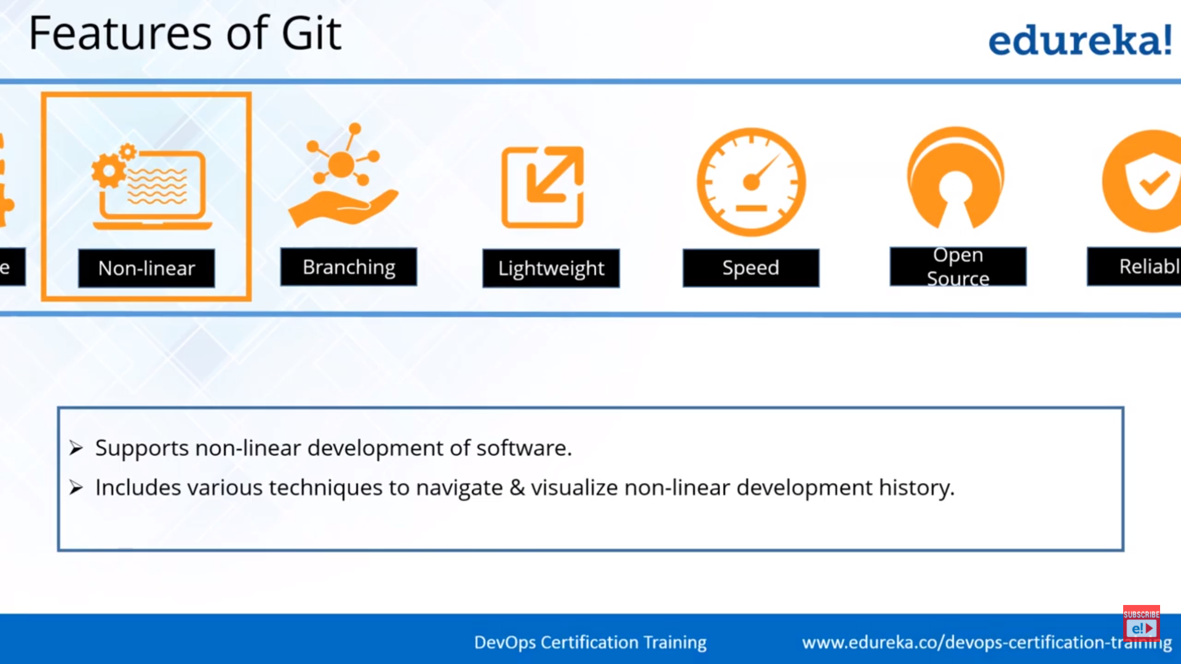

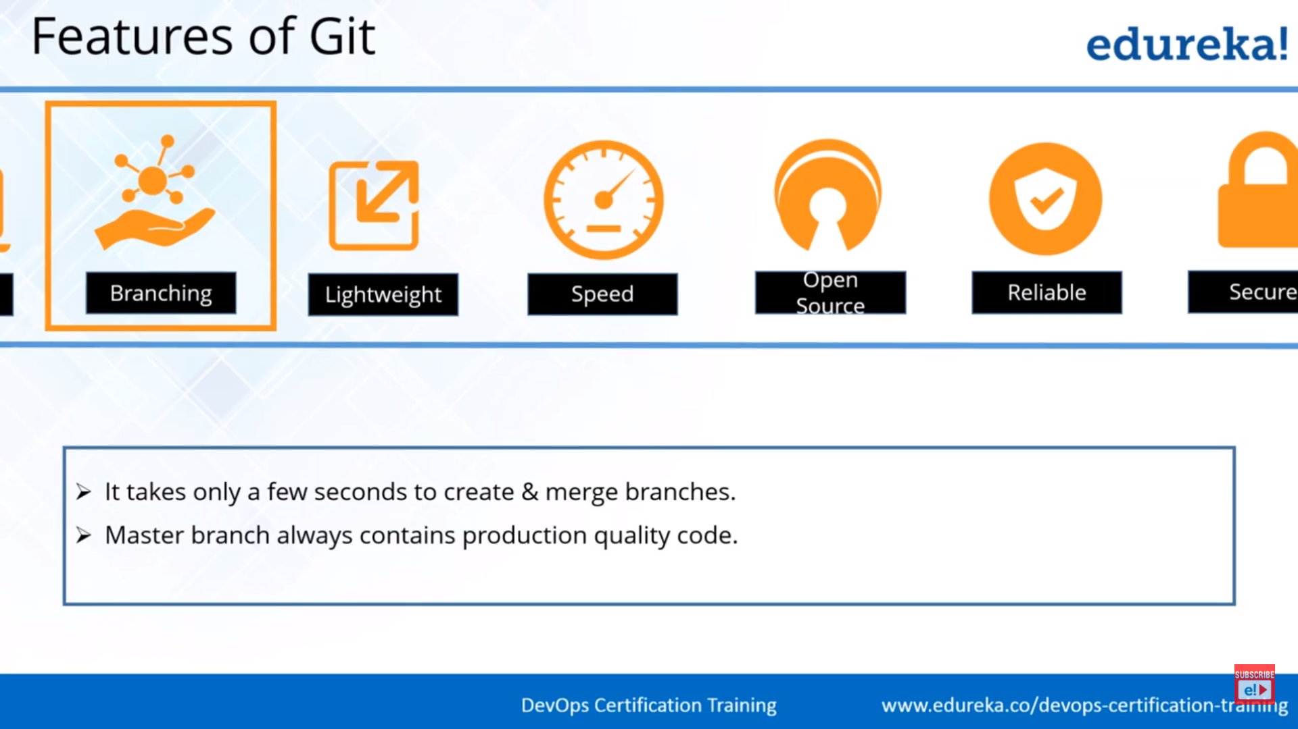

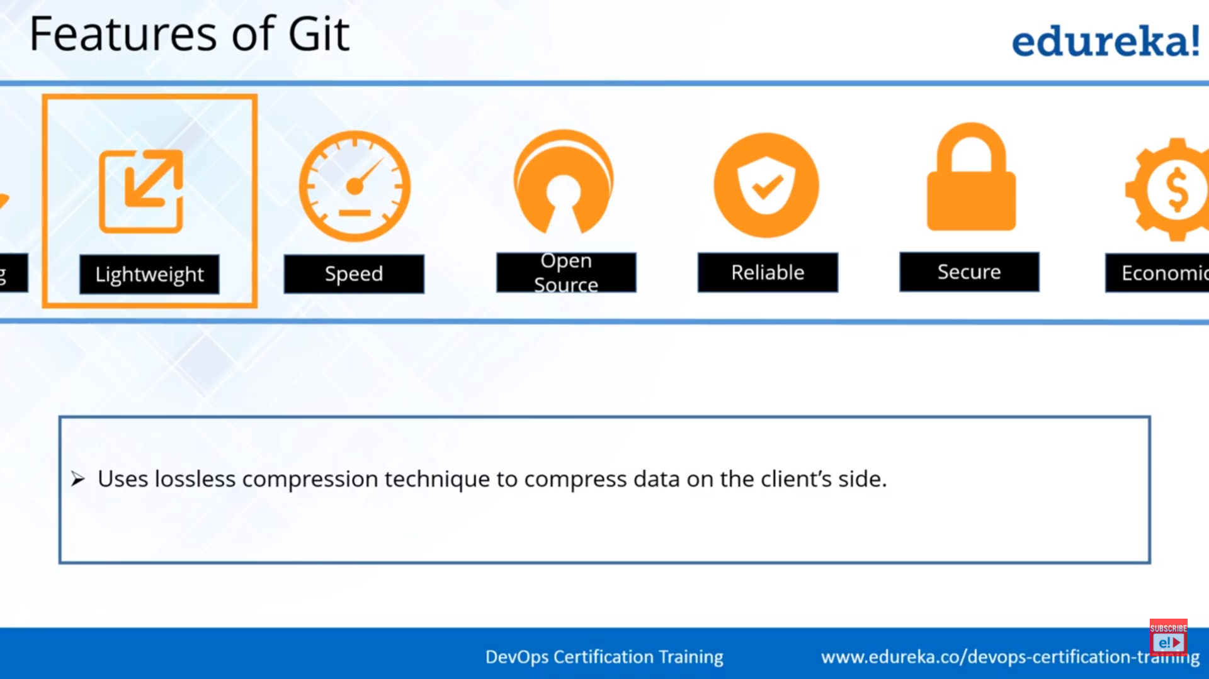

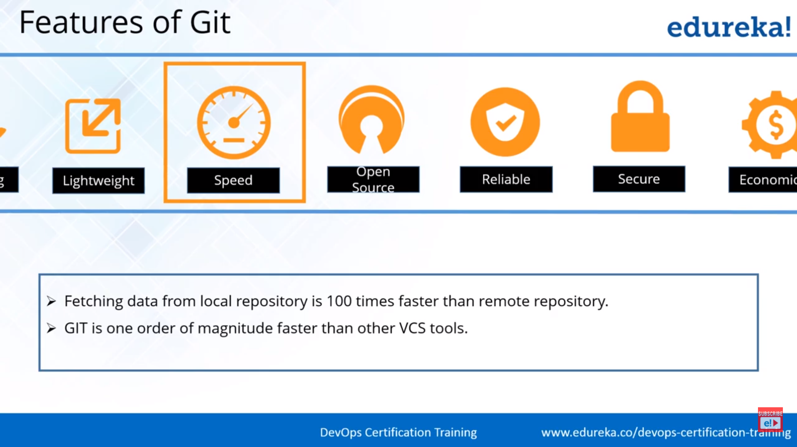



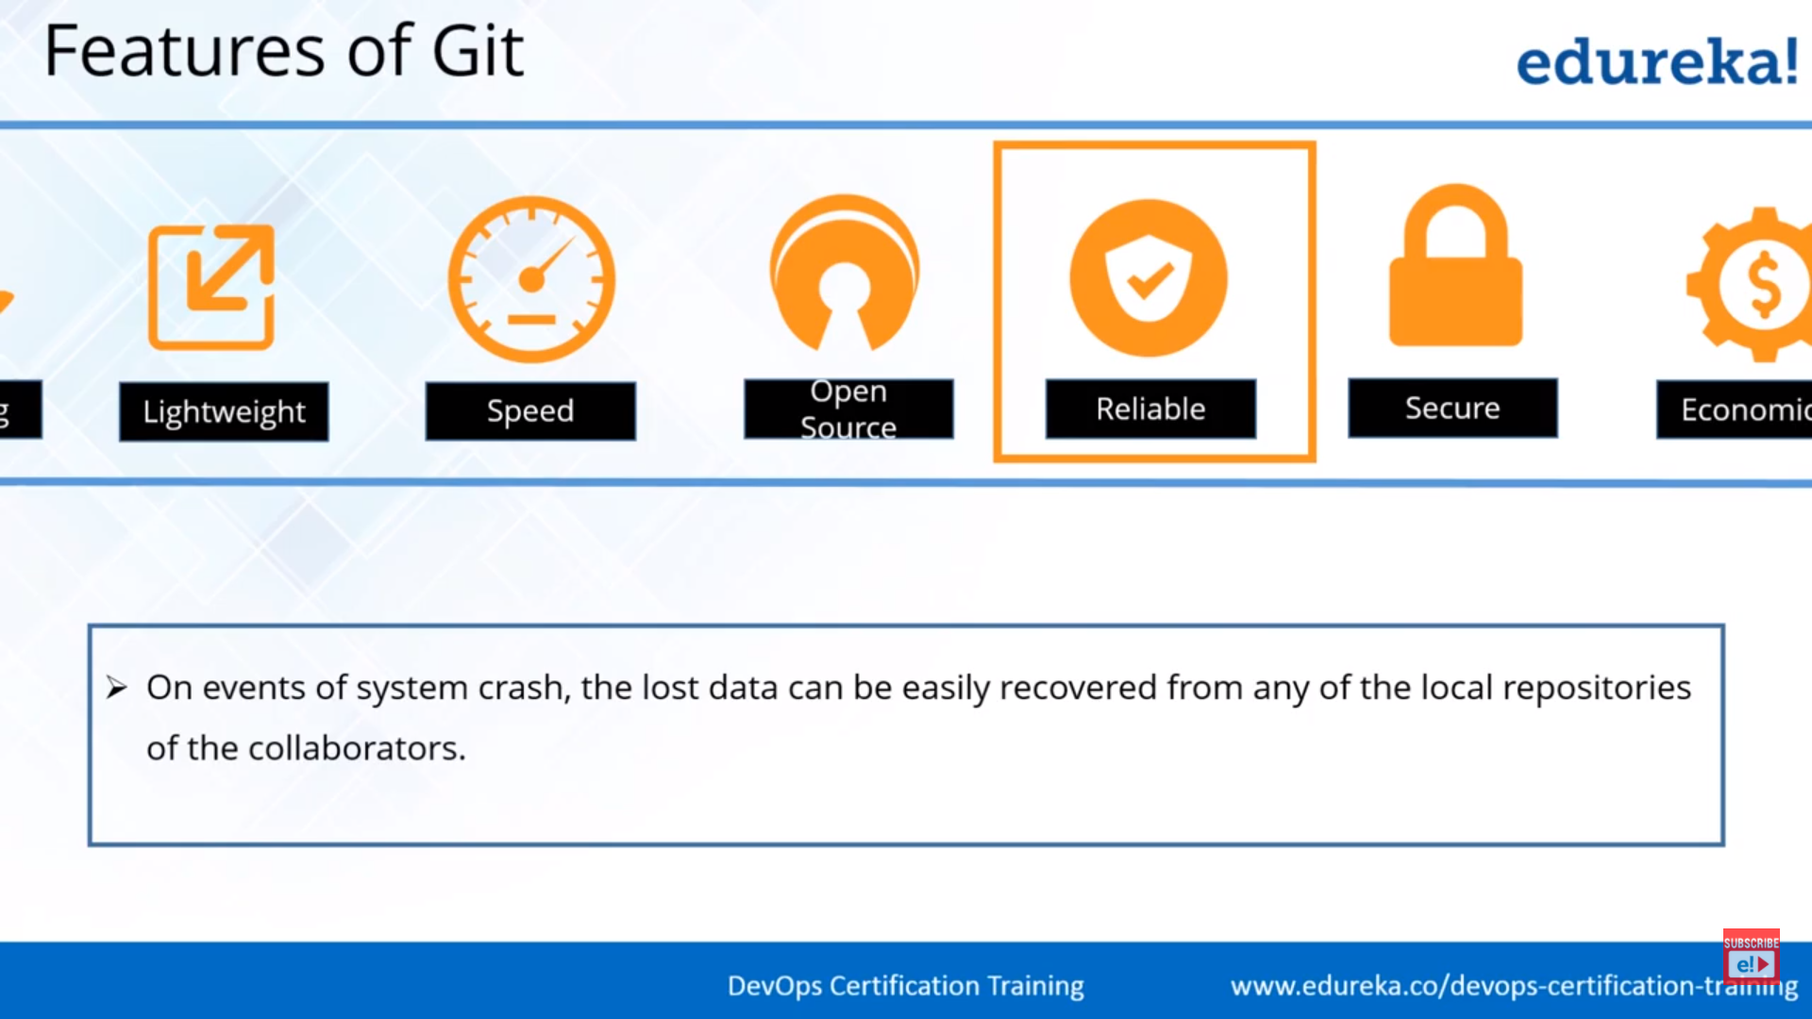

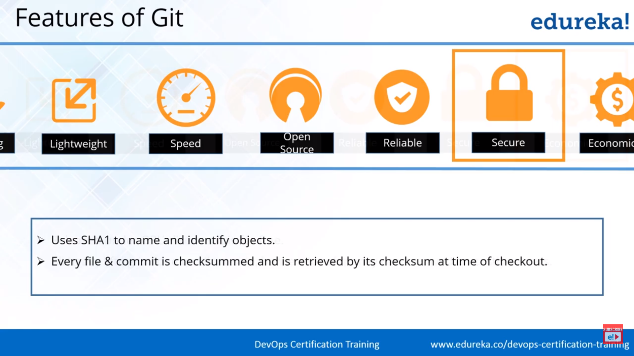

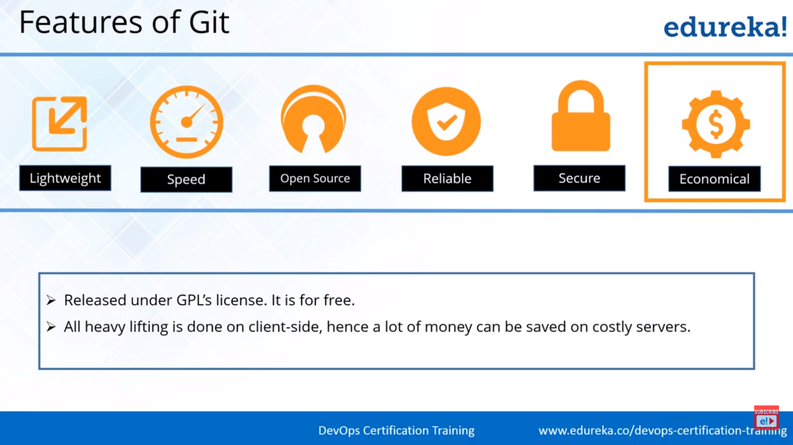

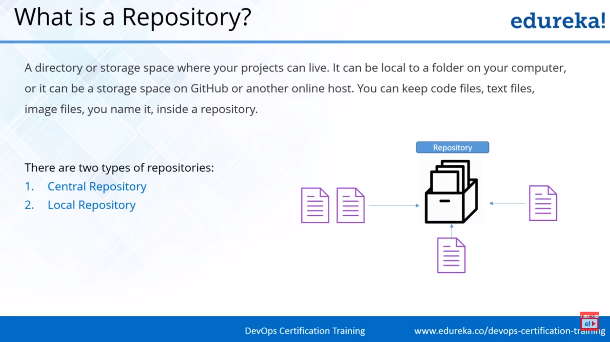

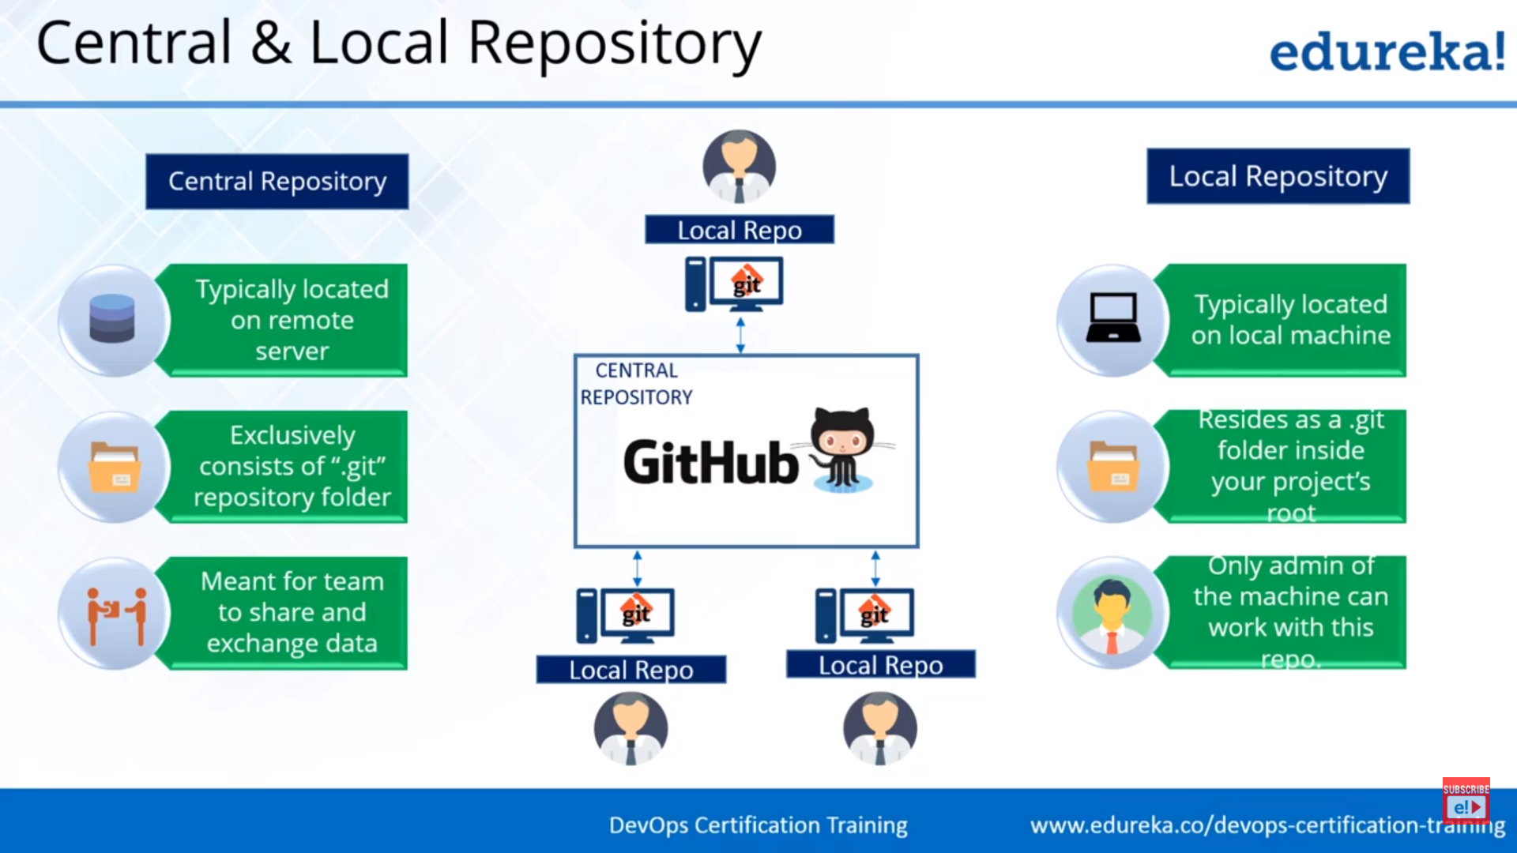

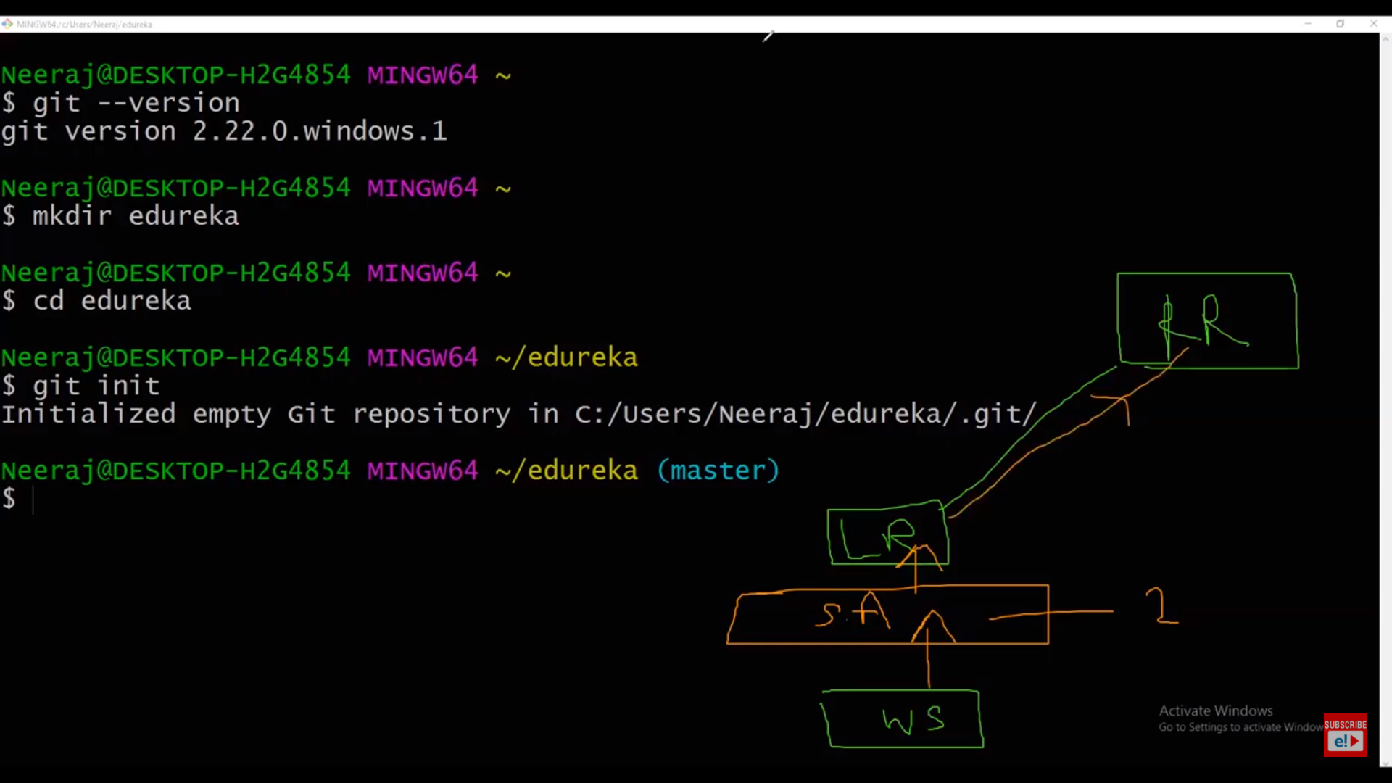

SA 🡪 Staging Area (Out of many files, only the required ones will be added here)

LR🡪Local Repository

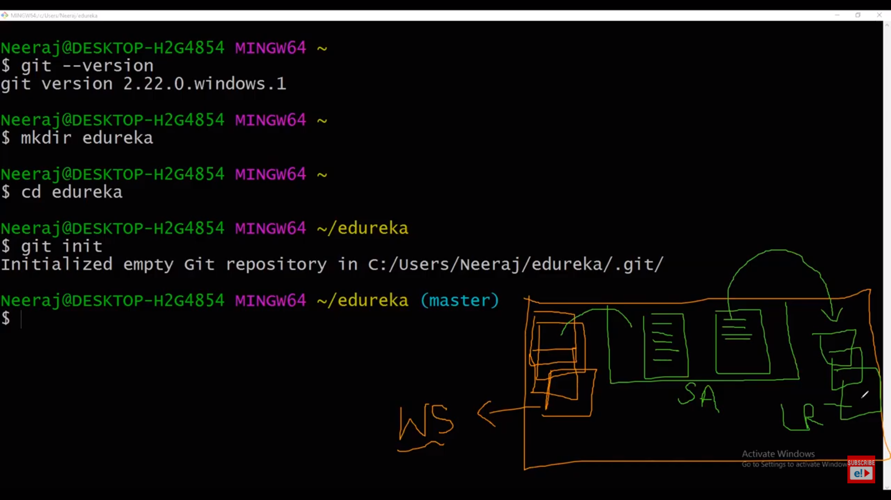

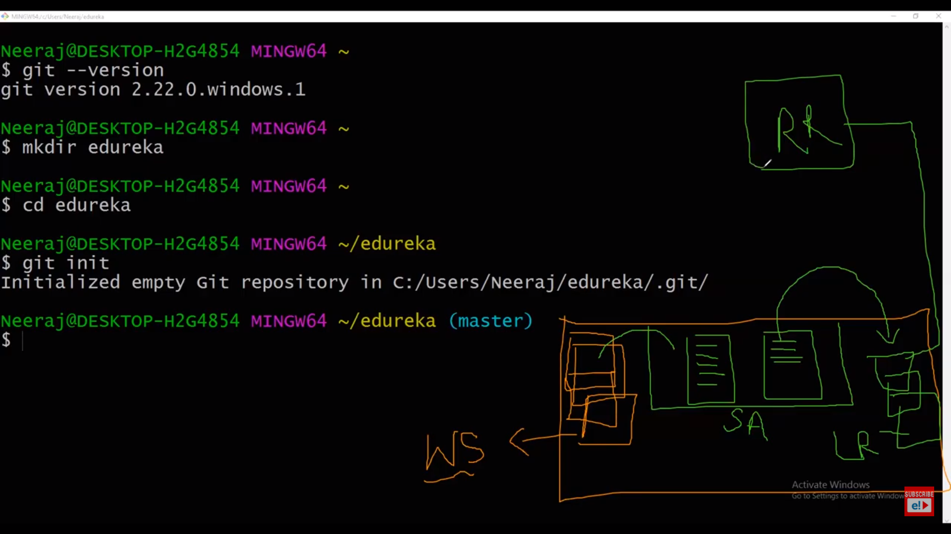

RR🡪Remote Repository

